2020
john cusey
CuseyHub
1/1/2020
Azure DevOps CI/CD Pipeline

Contents
1.1 What is CI/CD 2
1.2 Prerequisites (Accounts Need) 3
1.3 What is a task in Azure DevOps 4
1.4 Work With projects 6
Navigating Azure Dashboard 6
New Features 9
Create New Project 10
Delete a Project 11
Create New Pipeline 11
Running pipeline 14
How Fixing Error 16
2.5 Introduction CI/CD Java 19
References 20

Section 1: Introduction

1.1 What is CI/CD
DevOps
CI/CD (Continuous Integration/Continuous Deployment) pipeline, is the backbone of the modern DevOps environment. It bridges the gap between development and operations teams by automating the building, testing, and deployment of applications.

Writing Code | Commit (CI) | Build (CI) | Production Release (CD)
- Developers use IDE  - Code Review  - Writing Docs  - DBA work on SQL Scripts | - Developers push code to SCM (Git, GitHub, Bitbucket, GitLab  - Release Notes | - Compile application  - Unit Tests  - Static code analysis  - Jenkins | - Deploy Application to Dev, Test, Stage Environment  - UAT/UI Testing  - Release SQL Scripts

Source Code Management (SCM) is a software tool used by programmers to manage the source codes. SCMs are used to give versions/ revisions to the program. Each version is given a timestamp and includes the person responsible for the change. Even various versions can be compared and merged with other versions. Therefore SCM is also referred to Version Control, Revision Control or Source Control.
User Acceptance Testing (UAT) We know what testing is, acceptance means approval or agreement. The user in the context of a software product is either the consumer of the software or the person who requested it to be built for him/her (client).

1.2 Prerequisites (Accounts Need)

Azure DevOps
https://azure.microsoft.com/en-us/services/devops/
Expand beyond the limits of your current computing platform with the freedom to build, manage, and deploy your applications anywhere with Azure. Use your preferred languages, frameworks, and infrastructure—even your own datacenter and other clouds.
With help from Azure, you have everything you need to build your next great solution.

Visual Studio App Center
https://appcenter.ms
Visual Studio App Center is an integrated mobile development lifecycle solution for iOS, Android, Windows and macOS apps. It brings together multiple services commonly used by mobile developers, including build, test, distribute, monitoring, diagnostics , etc., into one single integrated cloud solution.

SonarCloud
https://sonarcloud.io/about
SonarCloud is the leading online service to catch Bugs and Security Vulnerabilities in your Pull Requests and throughout your code repositories.

Dockerhub
https://hub.docker.com/
Docker Hub is a hosted repository service provided by Docker for finding and sharing container images with your team. Key features include: Private Repositories: Push and pull container images. Automated Builds: Automatically build container images from GitHub and Bitbucket and push them to Docker Hub.

1.3 What is a task in Azure DevOps
In Azure develops CI/CD pipelines there are a group of different tasks that perform different operations. This could be running shell commands, copying files, and publishing them, install software and many more. You can search for more tasks by clicking on the plus sign.
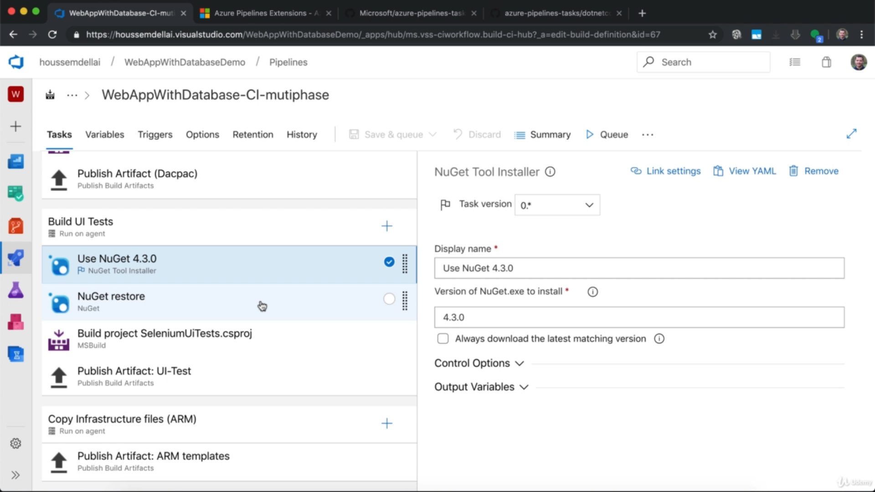

All the task can be found at Microsoft Marketplace.
https://marketplace.visualstudio.com

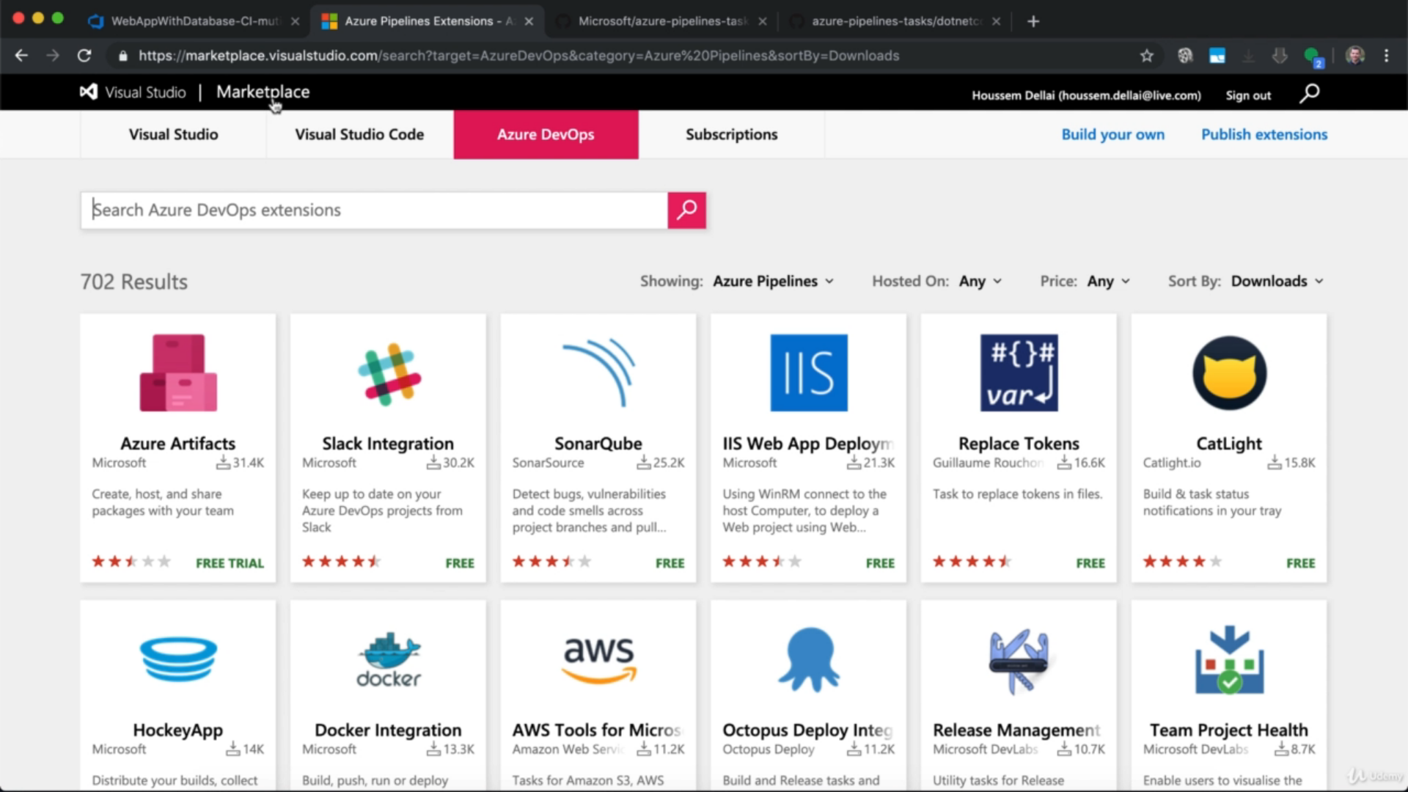
All the tasks can be found at GitHub
https://github.com/microsoft/azure-pipelines-tasks/tree/master/Tasks
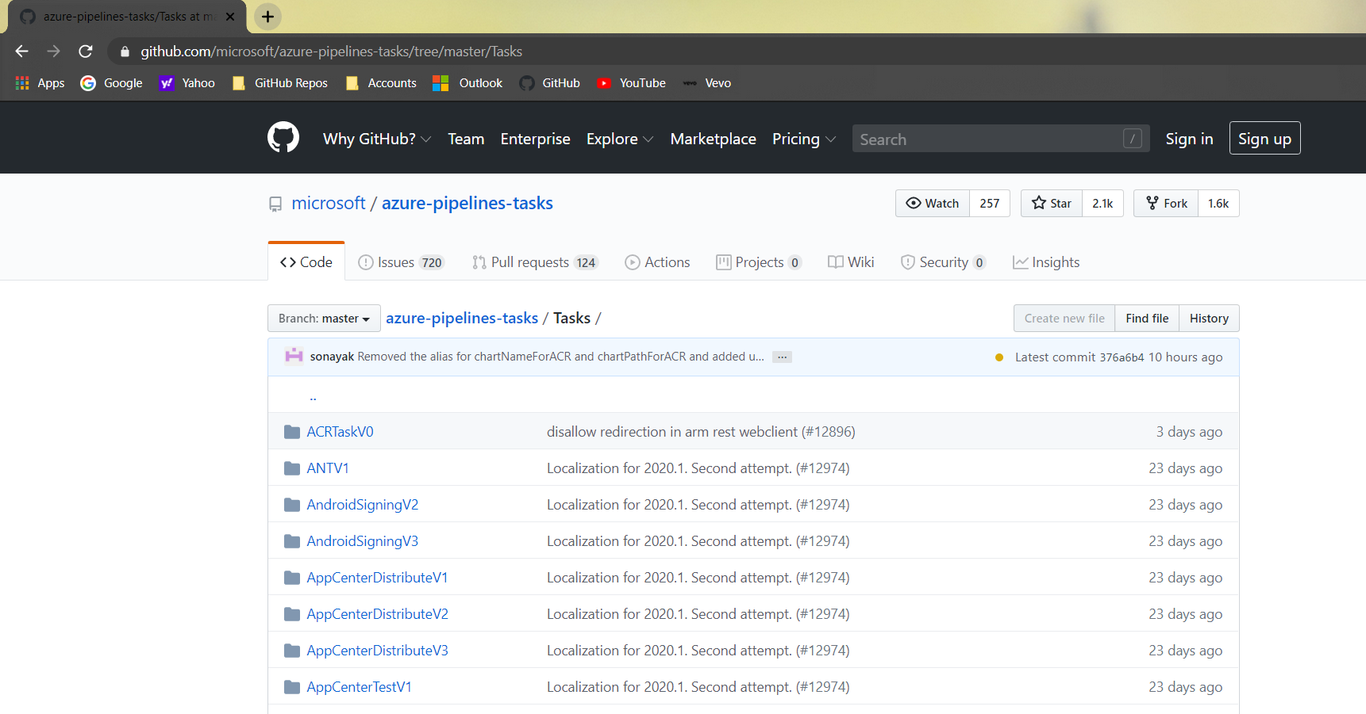
All tasks are written in Typescript.
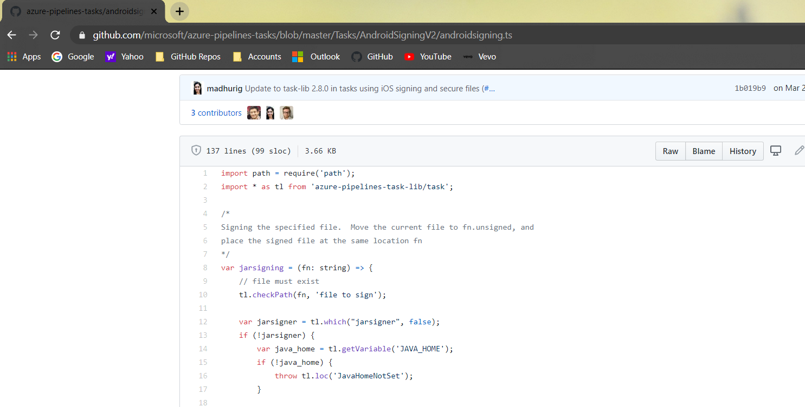

1.4 Work With projects

Navigating Azure Dashboard
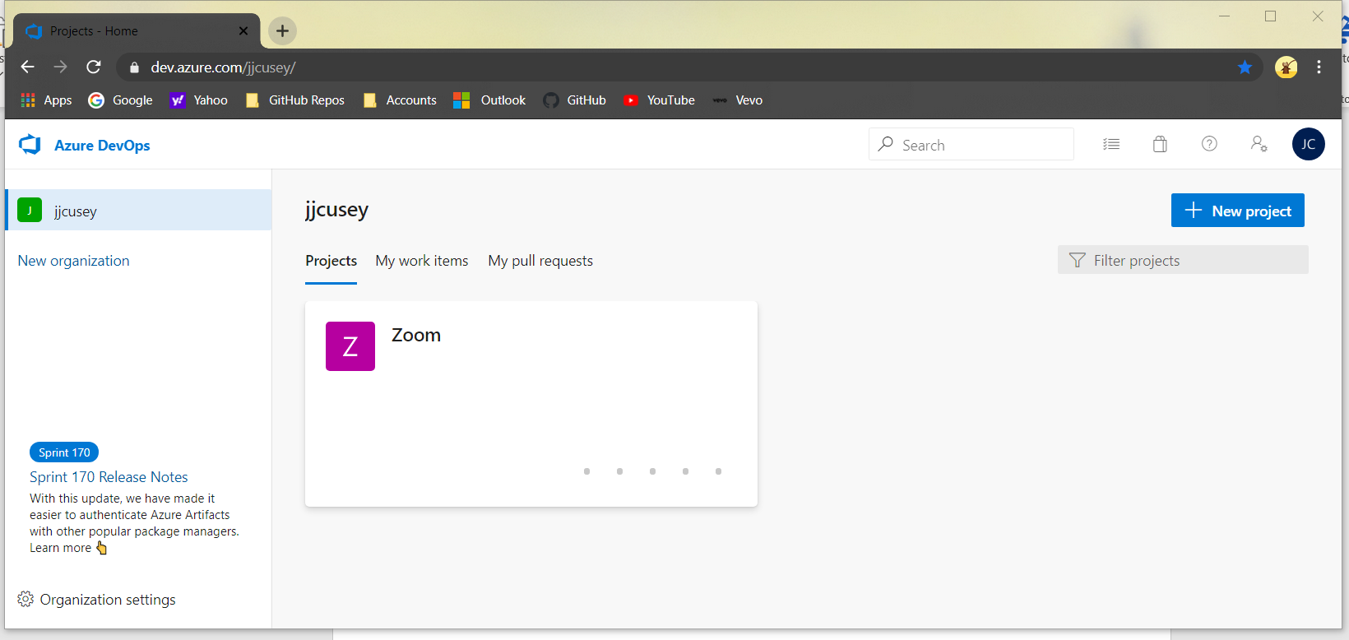

Figure 1.4.1 Azure Dashboard


Figure 1.4.2 Azure DevOps Home Icon

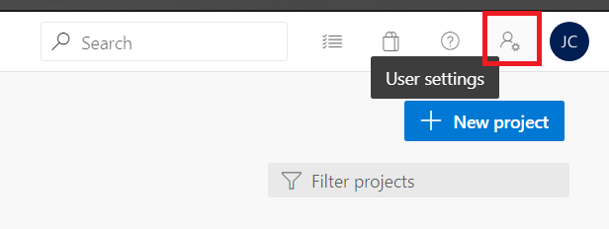
Figure 1.4.3 User Setting Icon

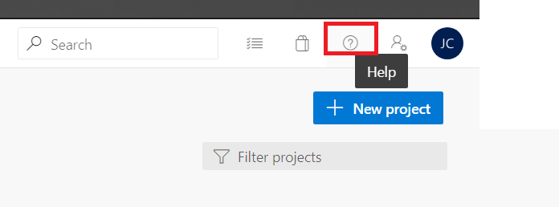
Figure 1.4.4 Help Icon

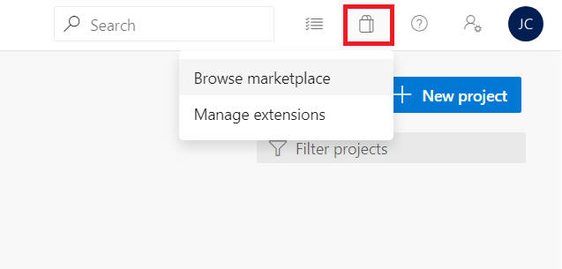

Figure 1.4.5 Marketplace Icon

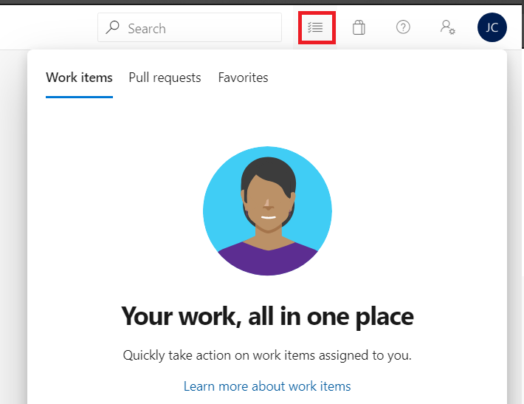

Figure 1.4.6 Work Items Assigned Icon


Figure 1.4.7 Organization Setting Icon

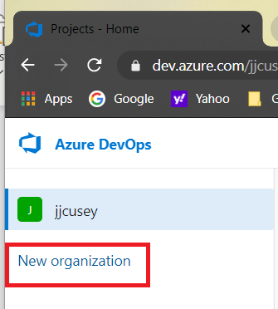
Figure 1.4.8 New organization Icon

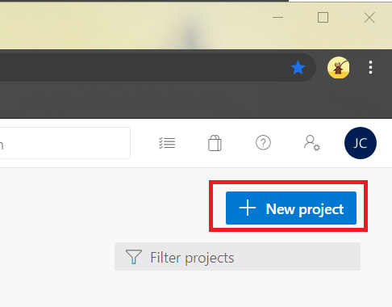
Figure 1.4.9 New project Button

New Features
Azure may include preview, beta, or other pre-release features, services, software, or regions offered by Microsoft.

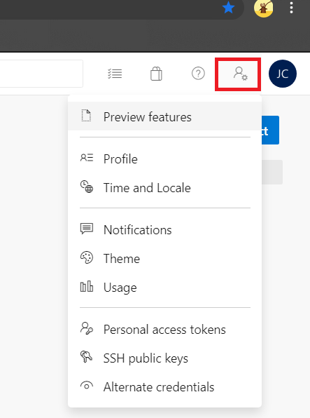
The select the new feature go to your Azure DevOps Dashboard click on the User Setting Icon, then select Preview features so you can add new features.

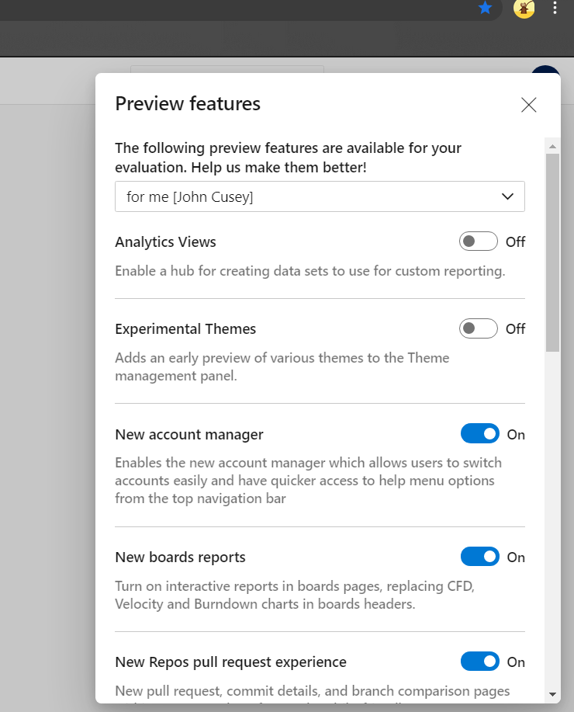
You select new features from the dialog box below you want to turn Off/On Switch.

Create New Project
.
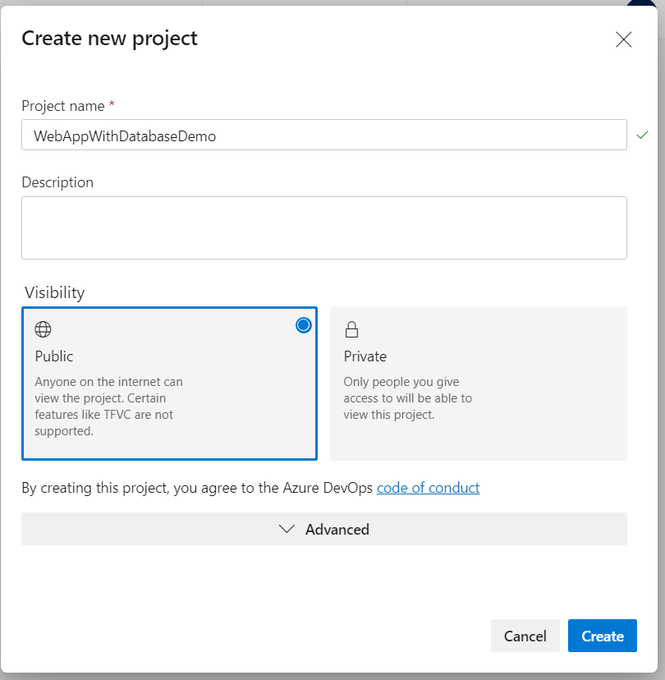
Go to Azure Dashboard and Click on New Project Button to create new project. Enter the Project Name, the visibility type which should be Public, then click on Create Button.

Delete a Project
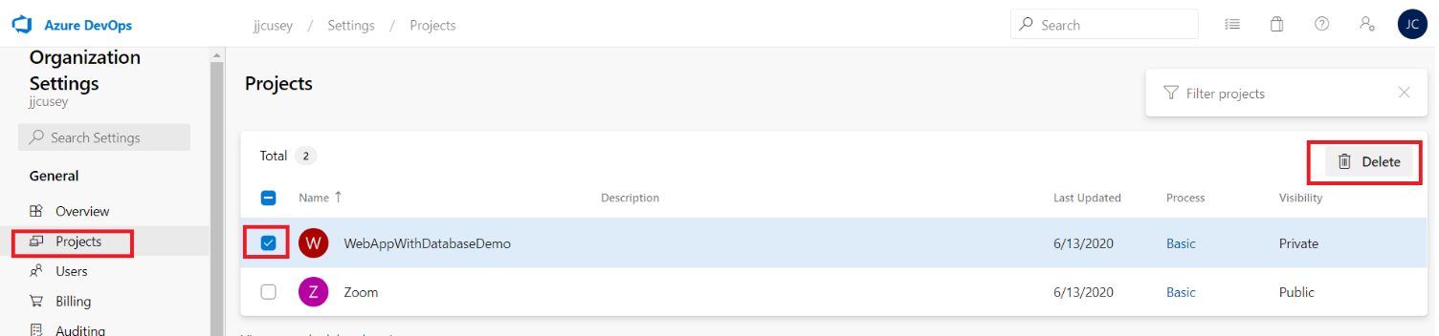
Go to your Azure Dashboard and select Projects form the vertical side menu. Then select the project want to delete and Delete Button.

Create New Pipeline
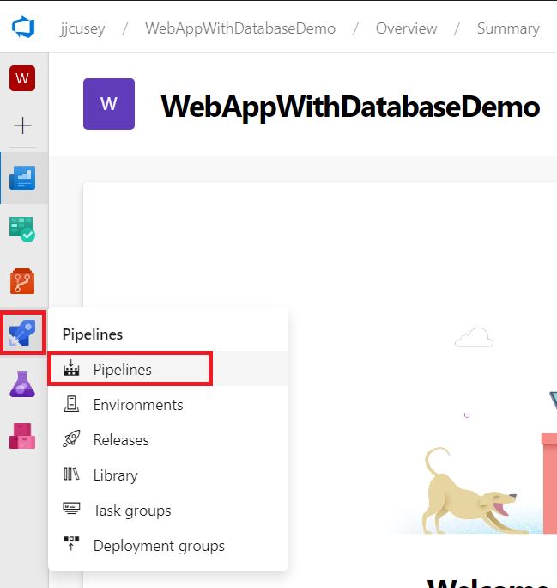

Select Pipelines
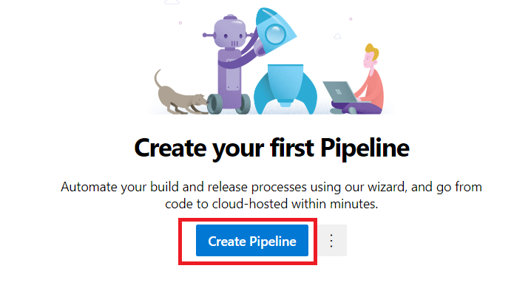

Click the Create Pipeline Button.

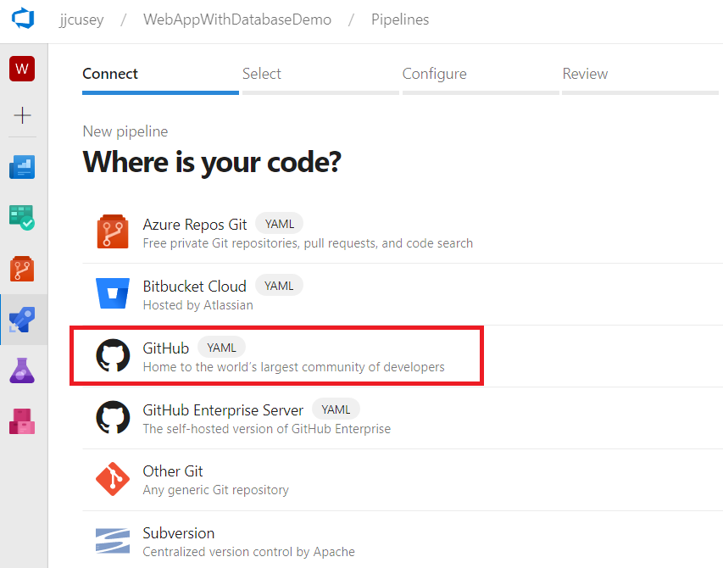

Most time you will select GitHub.

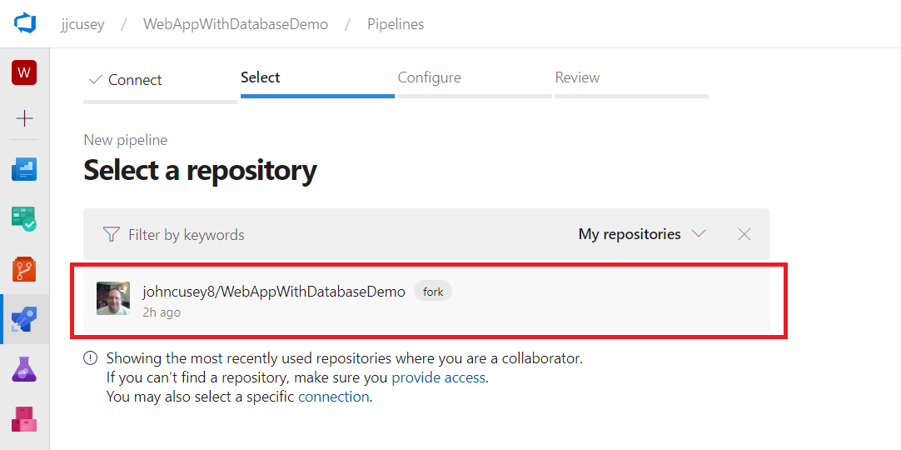
Select the repository you want to use.
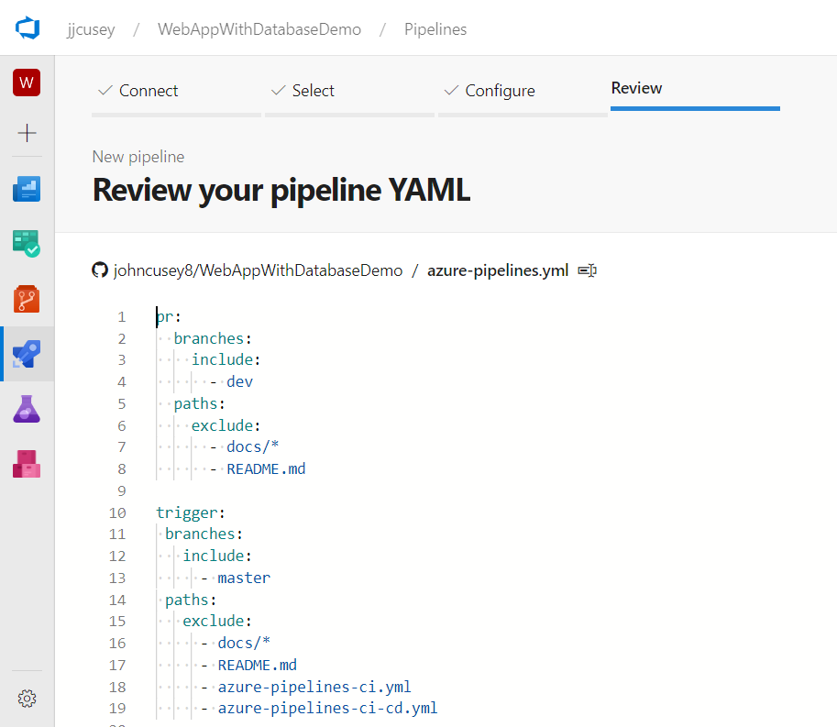

Running pipeline

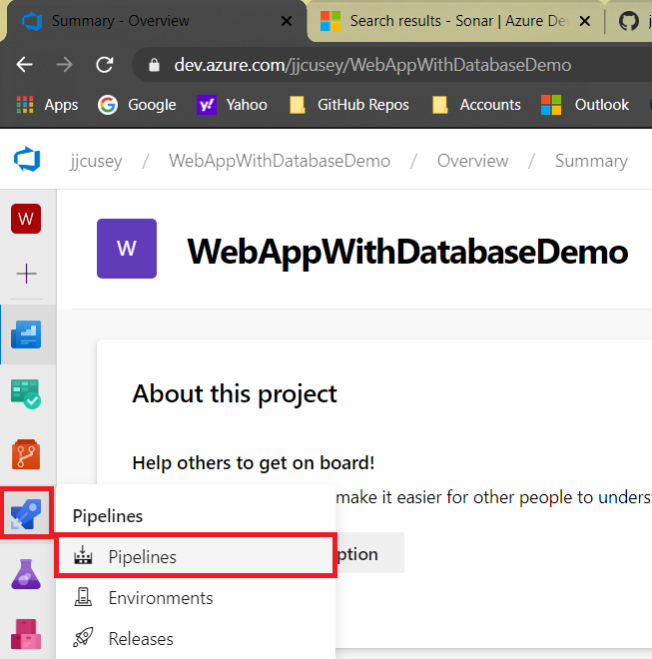

Go to the Pipelines
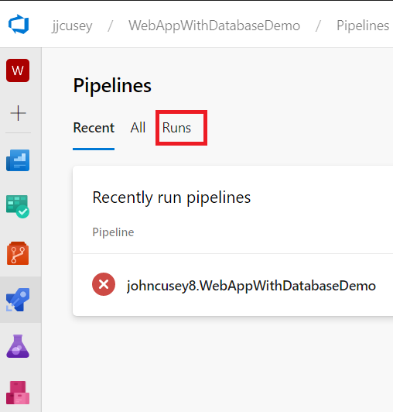

To look at all the recently runs clicks Runs icons

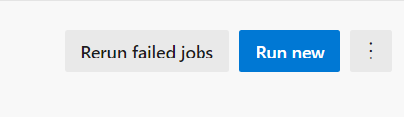

You can click on the Run new or Rerun failed jobs to run build again.

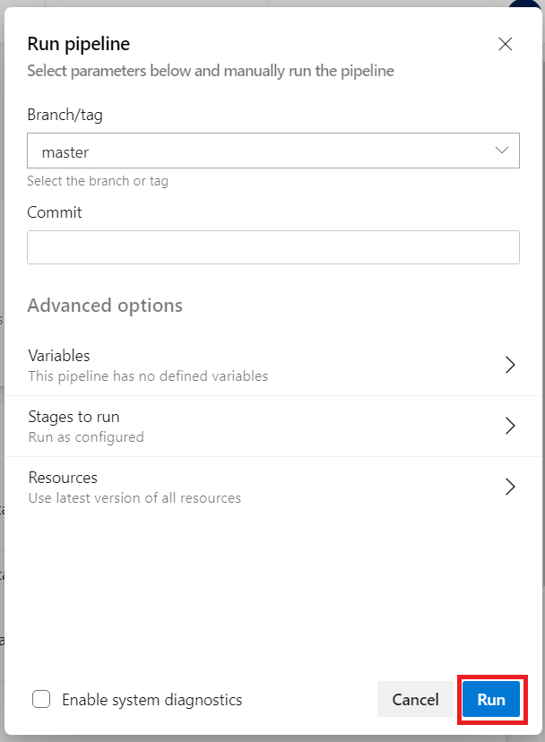

Click Run

How Fixing Error

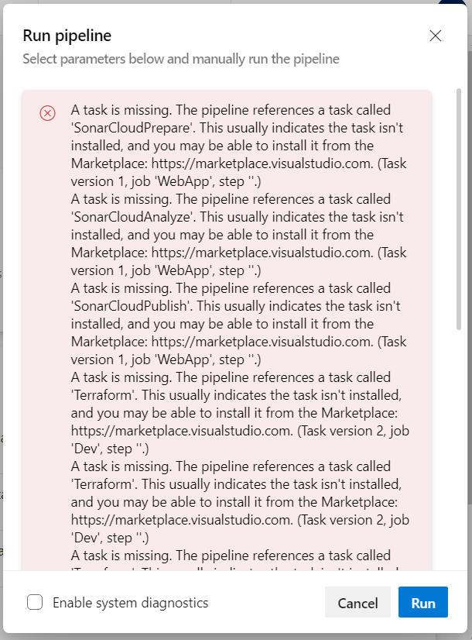
A task is missing. The pipeline references a task called 'SonarCloudPrepare'. This usually indicates the task isn't installed, and you may be able to install it from the Marketplace: https://marketplace.visualstudio.com. (Task version 1, job 'WebApp', step ''.)

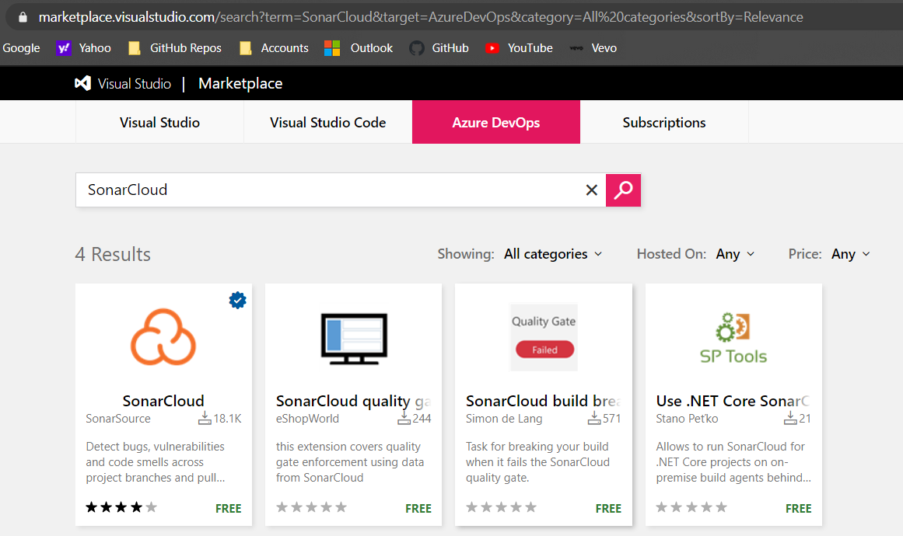
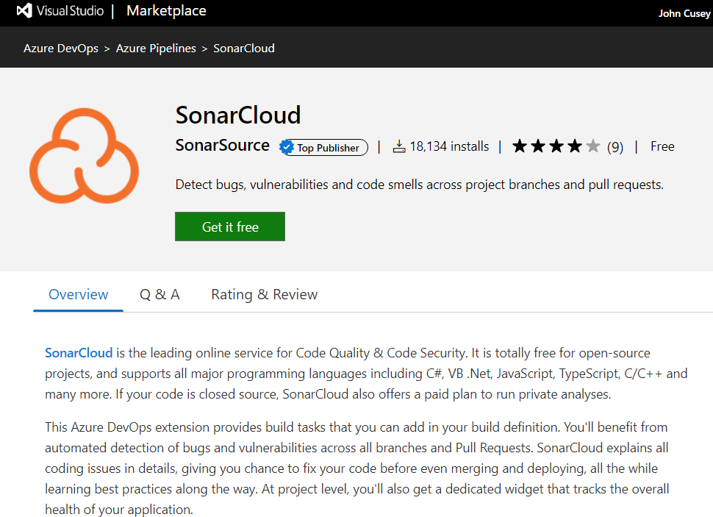
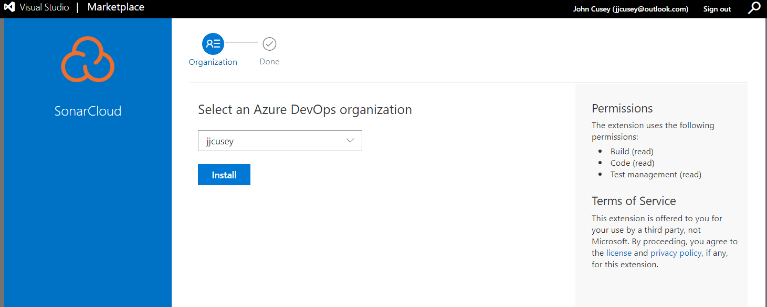

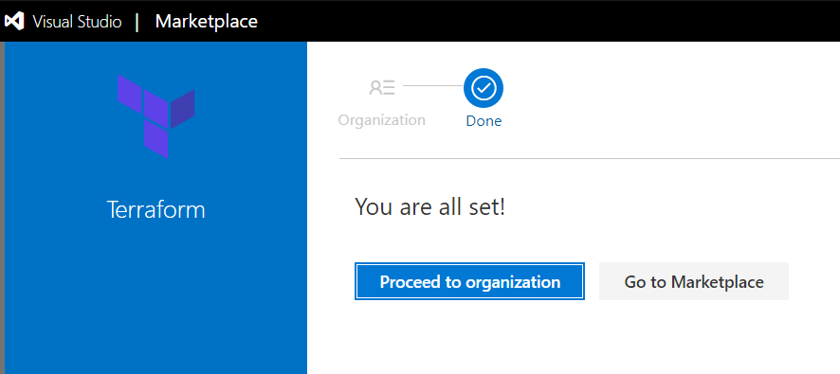

Section 2: CI/CD pipelines for Java app

2.5 Introduction CI/CD Java

References

Microsoft Officials Documentation
https://docs.microsoft.com/en-us/azure/devops/get-started/?view=azure-devopscould be running DMD commands running power shared scripts copying files and publishing them and

